ATLAS – AFMI
Association Francophone de Management International Treasurer : Sopie Nivoix
http://www.atlas-afmi.com sophie.nivoix@univ-poitiers.fr

11TH INTERNATIONAL CONFERENCE ATLAS-AFMI

3, 4, 5 MAY 2021

REGISTRATION FORM
Ms Mr First name : Last name :
PhD student Lecturer/Professor Non academic participant
Institution/ Organization :
Business address:
Post code : City : Country :
Phone :
E-Mail :
Billing address (if different) :

Post code : City : Country :

Conference fees⁽¹⁾
 | I contribute to the costs of the conference 2021 | I register for the conference, but I cannot participate
Lecturer/Professor ⁽¹⁾ | 350 € | 0 €
PhD student ⁽¹⁾ ⁽²⁾ | 250 € | 0 €
Non academic participant ⁽¹⁾ | 350 € | 0 €
- The Conference fees include membership of Atlas AFMI, access to all sessions, and the reception of the Atlas book resulting from the Fribourg conference (edition Vuibert).
- Important : Please attach a copy of your student ID card. This fee also applies to retired.

Date : Signature :

Payment (to be attached to the registration form) :
bank check (to Atlas-AFMI) bank transfer university payment order
For payment by wire transfer, please indicate the invoice number on the transfer order

Form to be sent with the payment NOT LATER THAN 10th APRIL 2021
by mail to : sophie.nivoix@univ-poitiers.fr

Atlas AFMI - Association Francophone de Management International

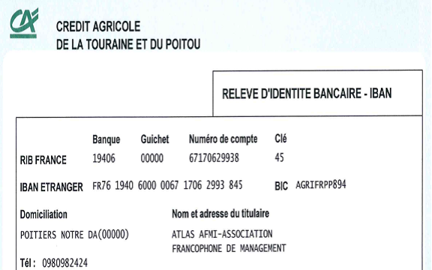

For any question about the wire transfer in France, please contact the treasurer of ATLAS-AFMI : sophie.nivoix@univ-poitiers.fr

